**Acknowledgement /email after every file transfer**

IBM Sterling integrator send files from one folder to other folder

1)Source Code for transfer file with acknowledgement :

<process name="Collect_And_Extract_TTR">

<sequence name="Sequence Start">

<operation name="File System Adapter">

<participant name="Collect_And_Extract_TTR" />

<output message="FileSystemInputMessage">

<assign to="Action">FS_COLLECT</assign>

<assign to="bootstrap">false</assign>

<assign to="collectionFolder">C:\Collect</assign>

<assign to="collectMultiple">false</assign>

<assign to="." from="*" />

</output>

<input message="inmsg">

<assign to="." from="Status_Rpt('status')" />

<assign to="." from="*" />

</input>

</operation>

<assign to="originalFileName" from="/ProcessData/FileName/text()" />

<operation name="File System Adapter">

<participant name="Collect_And_Extract_TTR" />

<output message="FileSystemInputMessage">

<assign to="Action">FS_EXTRACT</assign>

<assign to="extractionFolder">C:\Extract</assign>

<assign to="." from="*" />

</output>

<input message="inmsg">

<assign to="." from="*" />

</input>

</operation>

<operation name="File System Adapter">

<participant name="Collect_And_Extract_TTR" />

<output message="FileSystemInputMessage">

<assign to="Action">FS_COLLECT</assign>

<assign to="bootstrap">false</assign>

<assign to="collectionFolder">C:\Mail\Success</assign>

<assign to="collectMultiple">false</assign>

<assign to="deleteAfterCollect">false</assign>

<assign to="." from="*" />

</output>

<input message="inmsg">

<assign to="." from="Status_Rpt('status')" />

<assign to="." from="*" />

</input>

</operation>

<operation name="SMTP Send Service">

<participant name="InternalSMTP" />

<output message="SMTP_SEND_SERVICEInputMessage">

<assign to="xport-smtp-mailfrom">fg_sysadmin@IISCLIENT-com.eidikointernal.com</assign>

<assign to="xport-smtp-mailsubject" from="/ProcessData/originalFileName/text()" />

<assign to="xport-smtp-mailto">eidiko@IISCLIENT-com.eidikointernal.com</assign>

<assign to="." from="*" />

</output>

<input message="inmsg" />

</operation>

<onFault>

<sequence>

<assign to="." from="DOMToDoc(/ProcessData,'PrimaryDocument')" />

<operation name="File System Adapter">

<participant name="Collect_And_Extract_TTR" />

<output message="FileSystemInputMessage">

<assign to="Action">FS_COLLECT</assign>

<assign to="bootstrap">false</assign>

<assign to="collectionFolder">C:\Mail\Fail</assign>

<assign to="collectMultiple">false</assign>

<assign to="deleteAfterCollect">false</assign>

<assign to="." from="*" />

</output>

<input message="inmsg">

<assign to="." from="Status_Rpt('status')" />

<assign to="." from="*" />

</input>

</operation>

<operation name="DocKeywordReplace">

<participant name="MyDocKeywordReplace" />

<output message="outmsg">

<assign to="." from="*" />

<assign to="literal_mode">true</assign>

<assign to="literal_bufferSize">102400</assign>

<assign to="literal_readAheadSize">8192</assign>

<assign to="keyword1" from="string('&lt;![CDATA[')" />

<assign to="replace1" from="''" />

<assign to="keyword2" from="string(']]&gt;')" />

<assign to="replace2" from="''" />

</output>

<input message="inmsg">

<assign to="." from="*" />

</input>

</operation>

<operation name="SMTP Send Service">

<participant name="InternalSMTP" />

<output message="SMTP_SEND_SERVICEInputMessage">

<assign to="xport-smtp-mailfrom">fg_sysadmin@IISCLIENT-com.eidikointernal.com</assign>

<assign to="xport-smtp-mailsubject" from="/ProcessData/Prev_NotSuccess_Adv_Status/text()" />

<assign to="xport-smtp-mailto">eidiko@IISCLIENT-com.eidikointernal.com</assign>

<assign to="." from="*" />

</output>

<input message="inmsg" />

</operation>

</sequence>

</onFault>

</sequence>

</process>

Step1:login to IBM Sterling DashBoard

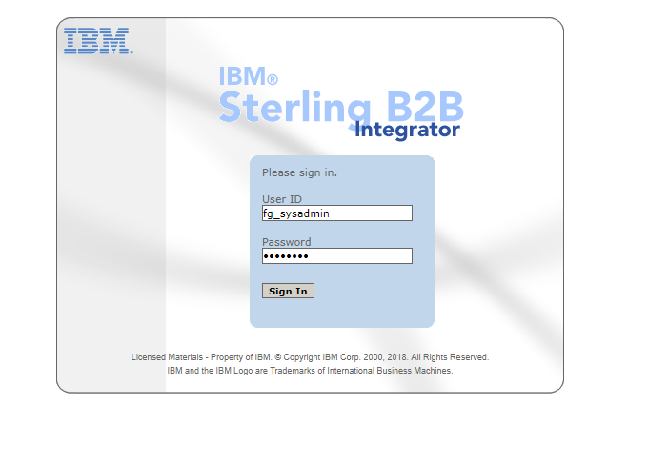

Step2: Go to Administration Menu >> Manager

click on the create process Definition Go Button

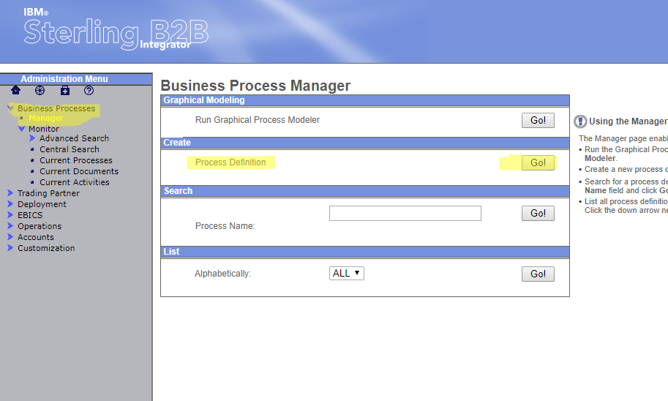

Step3: Give the Process Name and choose Business Process Text Editor to Paste you Code.

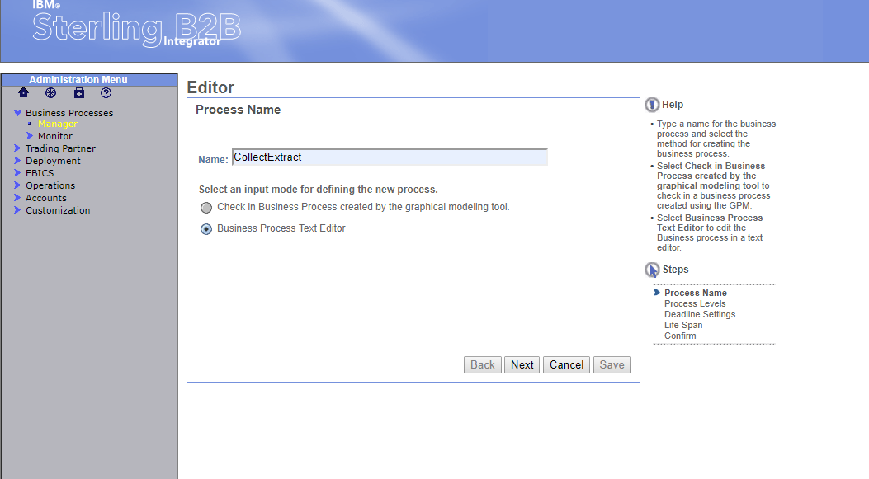

Step 4:Give the Description and Click on Next button and finish.

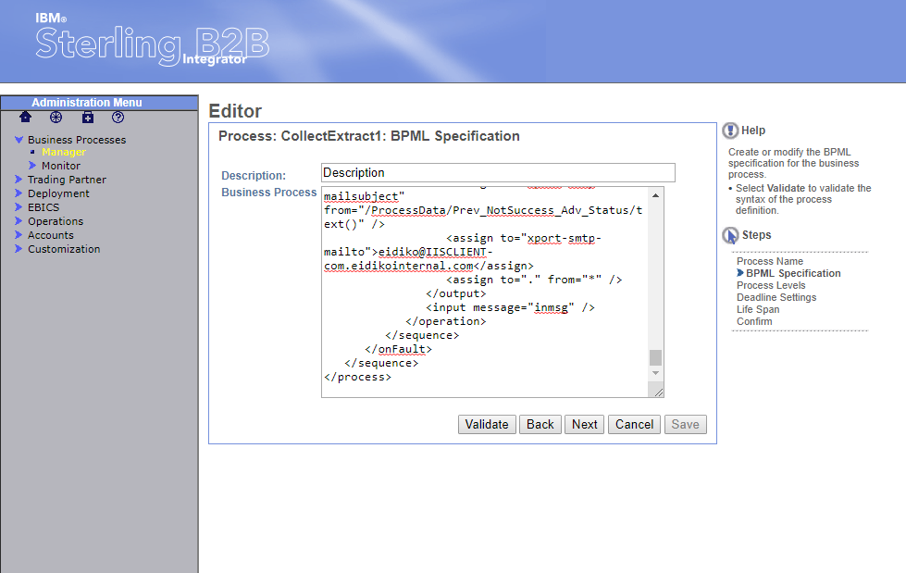.

Step 5:Go to Manger and search with Process Name

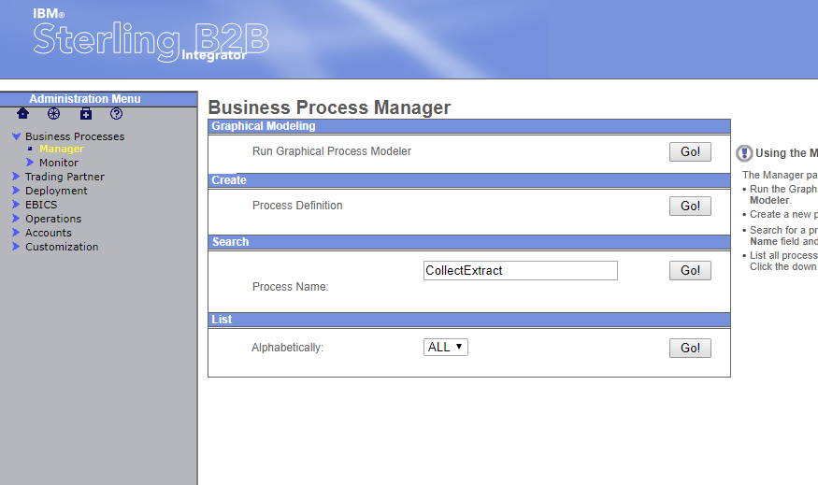

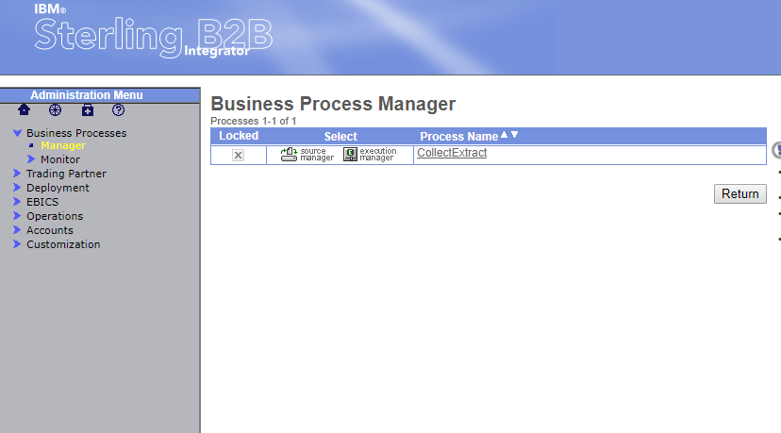

Step 6:Click on Execution Manager

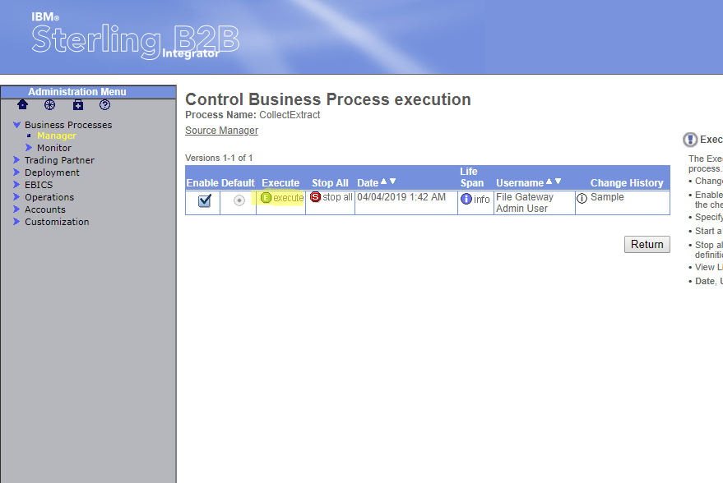

Click on Execute, User will be able to see below screen.

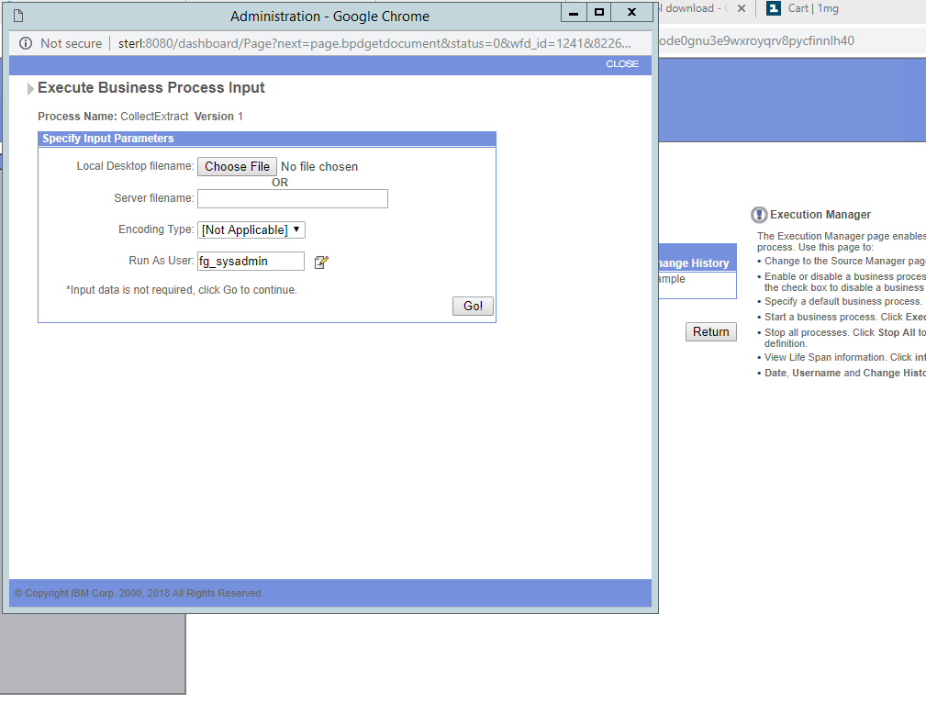

Step 7 :Click on Go button then instance will be get started, user can check in the Current Process

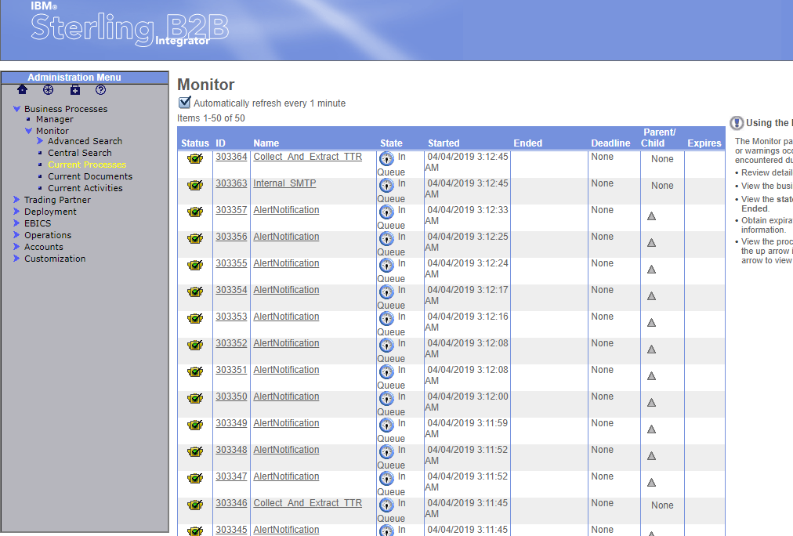

Step 7: Go and Check in the Server , whether the sterling integrator moved the files into destination and

check the Email id given in the Xml for Acknowledgement mail regarding Content Transfering.